
a
Company
Logotype

Cone Beam Computed Tomography- Report



Porur Dental X-rays & CBCT

Patient Name : Mr. Jaya Sundar | Date of Report : 01.07.2024
Age/ Gender : 40 years/ Male | Region of Interest : CBCT Maxilla
Referring doctor: 32 Dental Care | Indication : Nil
Clinical Notes: Nil
PATIENT INFORMATION

CBCT- Maxilla provided
CBCT – IMAGE DETAILS

RADIOGRAPHIC INTERPRETATION

- Completely missing crown and root portion in relation to 18, 27.
- Restored: 17.
- Hyperdense crown structure in relation to 11, 21, 22.
- Root stumps: 26, 27.
- The root fragment of 27 is present within the left maxillary sinus.
- The tooth 21, 22 is present with hyperdense restorative material within the pulp canal up to the apical third of the roots is evident. The periapical region of 21 is present with a diffuse hypodense region, measuring 4.55 x 8.74 x 8. 35 mm in dimension with irregular borders is evident. The periapical region of 22 is present with a diffuse hypodense region, measuring 5.32 x 8.15 x 8. 29 mm in dimension with irregular borders is evident.

IMPLANT ASSESSMENT

 | 26 region | 27 region
Sub-Crestal (in mm) | - | 7.67
Mid- Crestal (in mm) | - | 8.17
Distance between the alveolar ridge and floor of the maxillary sinus (in mm) | 2.07 | 5.37

RADIOGRAPHIC IMPRESSION

- Partially edentulous maxillary arch.
- Crown in relation to 11, 21, 22.
- Restored: 17.
- Root canal treated with periapical pathology: 21, 22.
- Root stumps: 26, 27.

Kindly correlate with clinical findings


IMAGES FOR REFERENCE

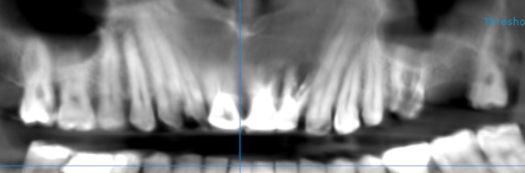
RECONSTRUCTED PANORAMIC VIEW

3-DIMENSIONAL VIEW
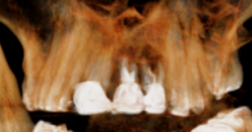

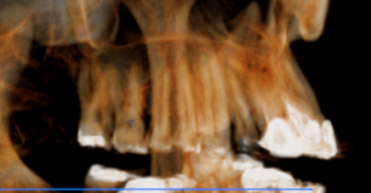
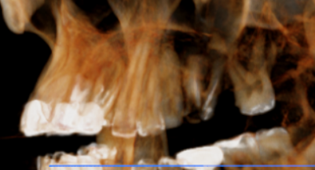

CROSS SECTIONAL VIEW

21 region | 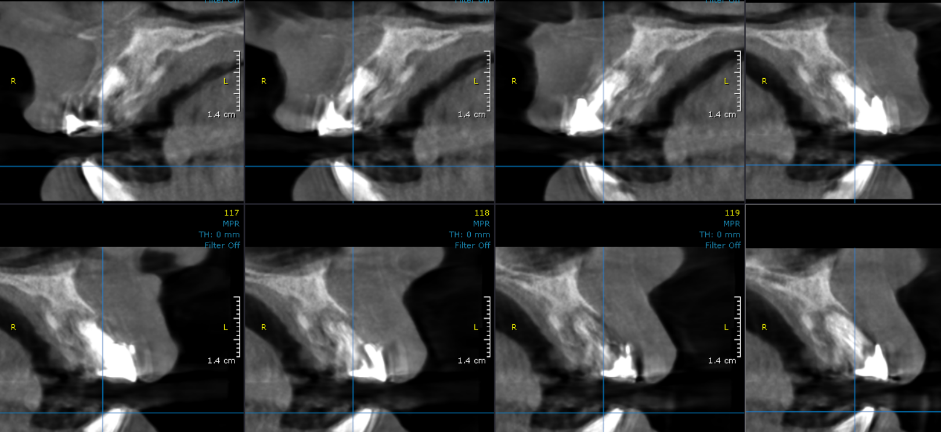
22 region | 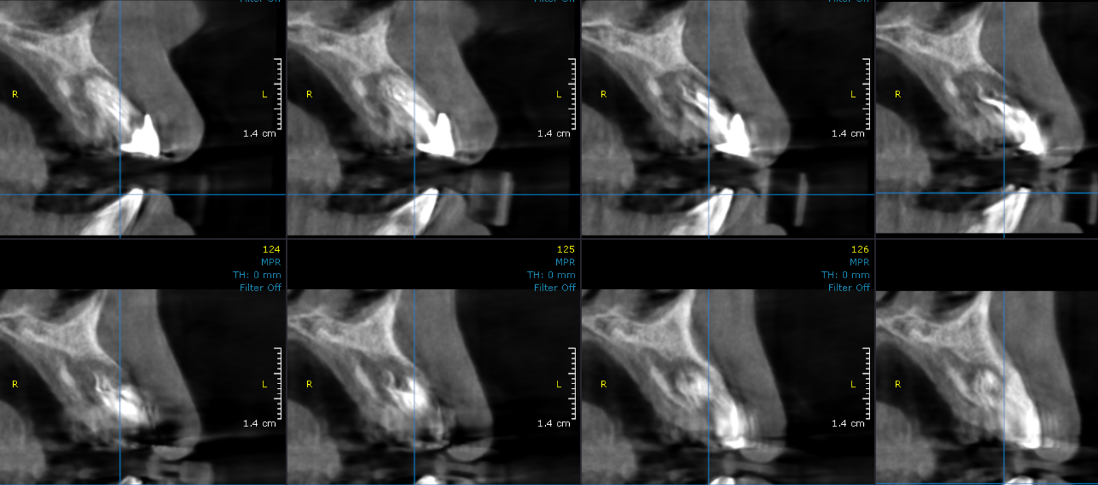
26 region | 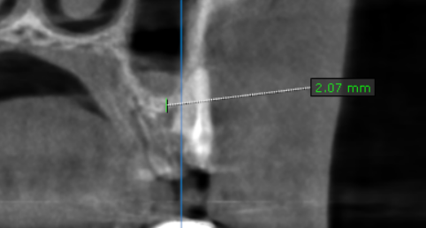
27 region | 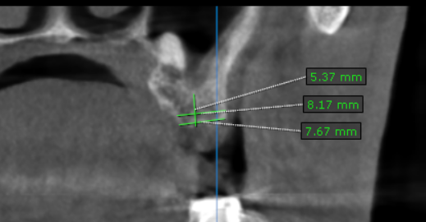  Root fragment of 27

**** End of report ****

